POWER HOUSE

FITNESS ACADEMY

**SOFTWARE REQUIEMENTS SPECIFICATION**

**For**

Web-Based Fitness Academy

Management System

**Prepared by Group CS 21**

University of Colombo School of Computing

Second Year Group Project

SCS 2202

**September 18, 2021**

**SCS2202 – Group Project I**

**2021**

**Software Requirements Specification**

Project Name : POWER HOUSE FITNESS ACADEMY MANAGEMENT SYSTEM

Group No. : CS 21

Group members :

|  |  |  |  |
| --- | --- | --- | --- |
| Name | Index No. | Reg. No. | E-mail |
| Kulasekara K. M. B. S. | 19000723 | 2019/CS/072 | 2019cs072@stu.ucsc.lk |
| Mahagamage P. S. | 19000881 | 2019/CS/088 | [2019cs088@stu.ucsc.lk](mailto:2019cs088@stu.ucsc.lk) |
| Wimalaweera N. S. | 19001967 | 2019/CS/196 | [2019cs196@stu.ucsc.lk](mailto:2019cs196@stu.ucsc.lk) |
| Dissanayake D. M. A. A. | 19000391 | 2019/CS/039 | 2019cs039@stu.ucsc.lk |

**Table of Contents**

**1.** **Introduction** 5

**1.1** **Purpose** 5

**1.2** **Document Conventions** 5

**1.3** **Intended Audience and Reading Suggestions** 6

**1.4** **Problem Domain** 6

**1.5** **Current Solution** 7

**1.6** **Limitations of the Current Solution** 7

**1.7** **Vision** 7

**1.8** **Goals and Objectives** 8

**1.9** **Proposed Solution** 8

**1.10** **Scope** 9

**2.** **Overall Description** 10

**2.1** **Product Perspective** 10

**2.2** **Product Features** 10

**2.3** **User Classes and Characteristics** 11

**2.4** **Operating Environment** 11

**2.5** **Project Constraints and Assumptions** 12

**3.** **Project Feasibility** 13

**3.1** **Technical Feasibility** 13

**3.2** **Economically Feasibility** 13

**3.3** **Legal and Ethical Feasibility** 14

**3.4** **Operational Feasibility** 14

**3.5** **Schedule Feasibility** 15

**4.** **Requirements** 16

**4.1** **Stakeholders** 16

**4.2** **Use Cases and Use Case Diagrams** 18

**4.3** **Use Case Narratives** 19

**4.4** **Functional Requirements** 28

**5.** **Quality Attributes** 30

**5.1** **Security** 30

**5.2** **Availability** 30

**5.3** **Reliability** 30

**5.4** **Modifiability** 30

**5.5** **Usability** 31

**5.6** **Maintainability** 31

**6.** **Proposed System’s Architecture** 31

**6.1** **Component and their responsibilites** 31

**6.2** **Component Interaction Diagram** 33

**7.** **System’s Design** 34

**7.1** **Class Diagrams** 34

**7.2** **ER Diagrams** 35

**7.3** **Sequence Diagrams** 36

**7.4** **Activity Diagrams** 45

**7.5** **State Transition Diagrams** 66

**8.** **User Interface Flow Diagram using wireframes** 77

**8.1** **User Interface Flow Diagram** 77

**8.2** **Wireframes** 79

**List of Figures**

**Figure 8.1: Flow chart** 6

**Figure 2.1: Project timeline** 15

**Figure 8.2: Use Case Diagram** 18

**Figure 8.24: Component Diagram** 33

**Figure 8.3: Activity Diagram - Sign Up** 45

**Figure 8.4: Activity Diagram - Login** 46

**Figure 8.5: Activity Diagram - Add User** 47

**Figure 8.6: Activity Diagram - Search User** 48

**Figure 8.7: Activity Diagram - Delete User** 49

**Figure 8.8: Activity Diagram - Manage Inventory** 50

**Figure 8.9: Activity Diagram - View income Report** 51

**Figure 8.10: Activity Diagram - Manage open/close date and time** 52

**Figure 8.11: Activity Diagram - Update Trainer Details** 53

**Figure 8.12: Activity Diagram - View Income** 54

**Figure 8.13: Activity Diagram - Set Availability** 55

**Figure 8.14: Activity Diagram - View Assign Users** 56

**Figure 8.15: Activity Diagram - Update Profile Details** 57

**Figure 8.16: Activity Diagram - Assign Trainer** 58

**Figure 8.17: Activity Diagram - Check Trainer Availability** 59

**Figure 8.18: Activity Diagram - Make Payments/Renew Membership** 60

**Figure 8.19: Activity Diagram - View Progress** 61

**Figure 8.20: Activity Diagram – Add/Update Meal plan and Schedule** 62

**Figure 8.21: Activity Diagram - Calculate BMI** 63

**Figure 8.22: Activity Diagram - Book a Trainer** 64

**Figure 8.23: Activity Diagram - Check Payment Details for Trainers** 65

# **Introduction**

## **Purpose**

This document reflects the Software Requirement Specifications for system – “POWER HOUSE”. This documentation is made before the development and implementation of the system to identify the purpose, functions and expectations of the system. Therefore the end release software may vary slightly to what is depicted in this document.

This document contains the data related to analysis, design and development of the system throughout its development cycle.

## **Document Conventions**

|  |  |
| --- | --- |
| SSL | -Secure Socket Layer |
| BMI | -Body Mass Index |
| HTTPS | -Hyper Text Transfer Protocol Secure |
| HTTP | -Hyper Text Transfer Protocol |
| HTML | -Hyper Text Markup Language |
| CSS | -Cascading Style Sheets |
| JS | -Java Script |
| PHP | -Hypertext Preprocessor |
| SQL | -Structured Query Language |
| URL | -Uniform Resource Locator |
| SRS | -Software requirement specification |
| DBMS | -Database Management System |
| AWS | -Amazon web services |
| EC2 | -Elastic Compute cloud |

## **Intended Audience and Reading Suggestions**

This document is mainly intended for developers and the supervisors of this system.Chapters 2 and 3 are recommended for parties who do not possess the technicalknowledge (such as Clients, Customers) but wish to know the process and the design of this system. For developers and supervisors, it is recommended to refer the whole document as it contains all the technicalities of the system throughout this document.

## **Problem Domain**

POWERHOUSE is a fitness academy currently managing its members and trainers manually. With growing up their members and trainers, it is hard to manage all the member details, trainer details, and scheduling.

### **Existing environment**

The new members come to the fitness academy, and they pay for the owner. Then the owner gets the details of the Member and issues a new card. When members wish to get a trainer, they pay for the Trainer as well. Members can work out without a trainer if they want to. The existing members renew their membership after the end of the period.

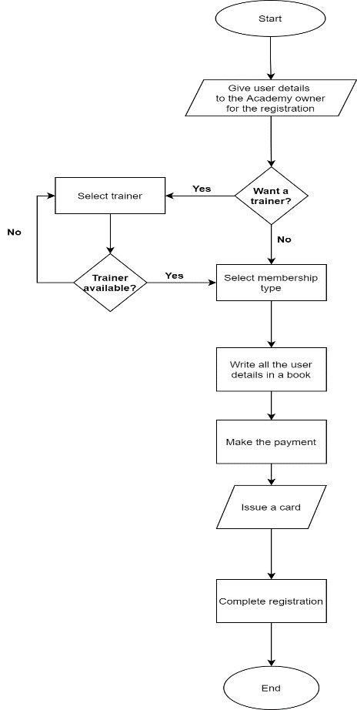**Flow Chart(For the xisting Workflow)**

**Figure 1.1: Flow chart**

### **Impact of the problem**

* Members do not have a way to know about the open-close times, Trainer's qualifications, and the Trainer's availability in the existing system.
* Members can not book their Trainer, and most of the assigned members for a trainer will come to the fitness academy at the same time.
* Members do not make the payment on time, and it is hard to calculate the income to the owner.
* Members do not have any idea about their BMI and progress.
* It is hard to maintain details of the members and the trainers in hard copies.
* Hard to update the meal plan and schedule of the members to the trainers.
* It is hard to maintain the inventory details.

## **Current Solution**

The fitness academy started five years ago. Still all the functions are done manually. The academy owner has a book that stores all the academy records such as user details, payment details, registration details, etc. The main problem is that even though the owner issues a card, the owner cannot quickly identify who has made the payment and who has not made the payment. The owner always needs to go through the records in the book and find the Member's name and see whether they have made the payment or not. Therefore currently there’s no viable solution whatsoever.

## **Limitations of the Current Solution**

* Hard to manage records
* Cannot notify members and trainers about the open/close dates and times.
* Trainers cannot track the progress of their relavant members.
* Members and Trainers doesn’t have a platform to manage their daily plans
* Academy management doesn’t have proper records in inventory.

## **Vision**

Our vision is to make an online fitness management system where members can manage access and track their progress and meal plans & schedules.Also increase interaction between members and trainers.

## **Goals and Objectives**

Our primary goal is to make an online fitness management system where members can manage access and track their progress and meal plans & schedules.Also increase interaction between members and trainers. We intend to achieve this through following objectives.

* Increase the relationship between trainers and members through an online platform.
* Providing the feature of book trainer, it saves the time of the member.
* With online payment system, members will pay on time. Therefore, it will be a positive impact for financial side of the academy.
* The member will be motivated with the progress tracking facilities.
* Trainers can train their members well because they will be more aware about their assigned member progress.
* All the records of each user will be stored and organized in an efficient way.
* Trainers can get an idea about past injuries of their assigned members.
* Any web user(visitor) can get an idea about the academy through website home page.

## **Proposed Solution**

POWERHOUSE FITNESS ACADEMY MANAGEMENT SYSTEM is a web-based platform established to manage all member details and trainer details of the academy with publishing more functionalities for all users.This management system will help the fitness academy management to operate their functionalities in a efficient and more faster way through an online platform.As a result of that registration process can be done more productively than before.

This system will be beneficial for our end users as follows;

* Fitness academy management can avoid the profit losses which they are facing now because the membership card will include a separate QR code.
* Fitness academy can easily retrieve required records beacused all the records will be stored and organized in the system.
* Academy management can make aware trainers and Members about the open/close times.
* Members will be able to view the progress and, the trainers also able to understand their relavant member progress.
* Also owner will be able to view inventory details.

## **Scope**

This project involves the building of an online web-based software solution for an existing fitness academy.

### **In – Scope**

* Visitor can register to the system as a member, online using the system.
* When signing up, visitors can pay the fee online or pay by cash later.
* Member can log in to the system and assign a trainer according to the Member's preference and the Trainer's availability.
* Admin can add, update, delete any user.
* Member can book their Trainer if the Trainer is available within that day.
* The Trainer can log in to the system and set the availability during that day.
* Admin can set open and close times of the fitness academy. Trainers and members can see that information.
* The Accountant can access and manage all the payment details and the payment reports.

### **Out – Scope**

* Online salary payment for the trainers.
* There is no way to communicate between the trainer and the member through the system.
* Trainers cannot sign up to the system by themselves.
* The system offers only English language and none offers Sinhala and tamil language options which is prominent in Sri Lanka.
* Trainers cannot be done through the system.

# **Overall Description**

## **Product Perspective**

Power House Fintess Management System is a new, self-contained product which intends to motivate the fitness people by providing an online platform for mambers, traienrs and all the stakeholders of the fitness academy. Members and trainers can interact more efficiently and plan their schedules and meal plans so that memebers can progress continiously.

Mainly, It is devided into 3 subsystems as follows.

1. **Member platfrom**

This is a system where memebrs can see their progress manage their meal plan and schedule. Through this system assigned trainer can interact with the memebrs by updating the meal plan and schedule. Also the trainers is able to see the memebr’s progress throght the system.

1. **Trainer platfrom**

Using this system, trainers can see their assigned memebers and and bokkings. Also the trainers is able to set his available times through the system. Also the trainers can go into the assigned memebers’ profils and update their meal plan and scgedule if necessary.

1. **Payment platfrom**

All the payments are processed here including signup payments and renew memwbership payments. This system uses PayHere as the payment gateway.

## **Product Features**

* Include phone numbers and other contacts with an option link to click and call.
* Members are able to book the trainer.
* System feedback feature.
* 24/7 operation
* Online payment method
* Resources page that contains blogs ,videos and tutorials.
* User based rating system for trainers
* Anyone can calculate bmi value feature

## **User Classes and Characteristics**

Four types of users will be using our system.

* Administrator
* Member
* Trainer
* Accountant

### **System Administrator**

This user is responsible for overall management of the system and has the highest level of privileges among all the user types. They can add or remove any element from the community.

### **Member**

Members are the clients of the fitness academy who are reigsterd to the system. They can access the member dashboard and do respective operations.

### **Trainer**

Trainer is a system actor who trains the members. They are responsible for updating the meal plan and schedules.

### **Accountant**

Accountant is a system actor who handles the financial side of the academy. He is responsible for accepting payments and paying for trainers.

## **Operating Environment**

**POWER HOUSE Fitness Management System** will mainly operate as a web application. It will be implemented to be responsive for whether its a PC, mobile or a tablet device so that it can be accessed via any internet enabled device. As a secondary measure it will also be operating as an Android application on Android. Both implementations require a working network connection (3G or higher).

## **Project Constraints and Assumptions**

### **Constraints**

* When the user signs up, all the submitting details go through validation checks, and if some input is invalid, the user cannot register and will be notified by an error.
* The number of members that can be assigned to a trainer at a specific period is limited. If the limit exceeds, no member can be set to that Trainer.
* Also, the number of bookings/appointments that a trainer can have within a day is limited.
* Registered users cannot remove their accounts by themselves. If necessary, a member needs to contact the Admin and request for the removal of the account.
* As hardware requirements, any user with a laptop/desktop and a desirable internet connection can access the system.
* The system is in English. Therefore the users should have basic knowledge of English.
* A system training should be given to the Admin and the Accountant.

### **Assumptions and Dependencies**

#### **Assumptions**

* + Admin can add trainers to the system only after validating their information and qualifications.
  + The user has a stable internet connection and basic IT literacy to operate the system.
  + The Admin knows the qualifications that a trainer should have.
  + The users have basic knowledge of English to use the system.
  + The users have the basic technical knowledge to use the system.
  + The users will provide the correct information.

#### **Dependencies**

* The web application will be hosted on the AWS server(Amazon EC2).

# **Project Feasibility**

## **Technical Feasibility**

This system is a web-based application that can be accessed via a browser. Its most important component will be a robust database. This database will be built using MySQL, which is open-source.

The system's web-based interface will be built using HTML5, CSS3, and JavaScript, all of which are open-source technologies. The backend of this system will be developed in PHP to connect these two components. These frontend and backend technologies will ensure data security while maintaining accuracy, reliability, and simplicity of access. As a result, the system's coding phase is technically possible.

When team members cannot meet physically because of this pandemic situation, online collaboration technologies such as Google Drive, Google Docs, GitHub, MS Teams, and Zoom meeting platforms are use to communicate with each other. These tools offer free service packages that can satisfy the requirements for this system's development.

The main reason we use PHP over Java is the speed. PHP is much faster than Java. Also, when developing PHP tends to have fewer issues.

We select MySQL because the system generates various types of reports such as progress reports, profit reports, etc. For this process, the relational database is much more efficient than the non-relational database.

Since this is a system for a fitness academy, there will be no considerable number of records to be stored in the system. So, it is efficient to use MySQL.

Therefore we can conclude that the system will be technically feasible.

## **Economically Feasibility**

A group of 4 university students develops this system. Therefore, the cost for the developers can be counted as none.

It is shallow when considering the development cost because it is developed from open-source software tools and languages. The development of the website will be carried out from HTML, CSS, JavaScript, MySQL, and PHP.

The web application will be hosted using a dedicated Amazon EC2 server. The web server provides secure, resizable compute capacity. The dedicated hardware of 4GB RAM and two core CPU will be sufficient at the start. The deploying cost will be $35-$55 for a year. Therefore, we can conclude that the system will be economically feasible.

## **Legal and Ethical Feasibility**

This is the measure of how well a solution can be implemented within existing legal and contractual obligations.

* **Privacy of information**

All the sensitive information regarding the members and the trainers is not visible to the unregistered users. Also, the member details are not visible to the other members. Here, we are going to implement authentication levels in the system. According to the authentication levels, the system users could access the data. So the privacy of information is highly protected.

The authorized user could modify the system data according to the authentication levels.

* **Handling user data**

The user data will not be exposed to external parties under any condition. Only the registered users of the system would be able to access the system data. In legal terms, there are no issues involved with this system as our system does not break any rules and regulations under the laws in our country. Also, there are no contractual obligations. Hence, measures have been followed to ensure that no legal or ethical issues occur within the system.

So that we can conclude that our system will be legally feasible.

## **Operational Feasibility**

The proposed system could be used by the trainers and the members of the Fitness Academy. The records are manually recorded in books in the existing manual system, and there is a significant time delay when referring to these books. Old documents can be damaged or destroyed with time. However, with the new automated system, Admin may access all the efficiently saved records. Furthermore, because the documents have gone through many verification steps, they are more reliable in the system.

The automated system makes an efficient relationship between members, trainers, and Fitness Academy administration. We prioritized the system's efficiency and user-friendliness over its attractiveness and complexity.

Data security and reliability are also taken into account. Because unregistered users cannot view the profiles, the suggested system can securely store the data to be used. Registered users will be given a username and password. They can use it to access the system.

A web-based system is what we have suggested. As a result, it may easily be expanded, and any user with an internet connection can join the system within the system's limitations. Unregistered users can find their BMI status only.

Members can assign a trainer at their convenience. However, trainer assignment is not obligatory. Members can pay fees online or by cash. The system accountant handles the financial side of the fitness Academy.

## **Schedule Feasibility**

The group includes four members with varying abilities. Therefore, the project's scope can be completed within the given time frame.

The system will be completed over an academic year. The requirement analysis phase took about a month, resulting in the clear identification of the requirements.

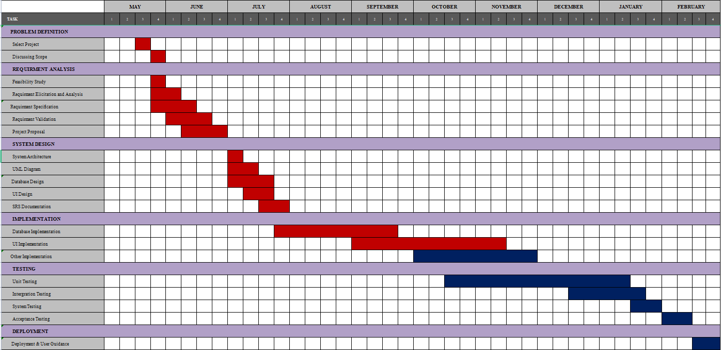The following figure depicts the project timeline throughout the year.

**Figure 3.1: Project timeline**

# **Requirements**

## **Stakeholders**

**Visitor**

* Sign up
* Calculate BMI

**Member**

* Login
* View Progress
* Add/ update meal plan and schedule
* Send notification
* Make payment / renew membership
* Update profile details
* Check trainer availability
* Check trainer assign limitation
* Assign Trainer
* Check trainer booking limitation
* Book trainer

**Trainer**

* + - Sign up
    - Login
    - Update trainer details
    - Set availability
    - View Income
    - View assigned members
    - View progress
    - Add/ update meal plan and schedule
    - Send notification

**Accountant**

* Login
* View income report
* Make payments / renew memberships
* Check payment details for trainers

**Admin**

* Login
* Add user
* Search user
* Delete user
* Manage inventory
* Manage open/close date and times
* View income report
* Update profile details
* Update trainer details

## **Use Cases and Use Case Diagrams**C:\Users\ACER\Desktop\Use Case 2.png

**Figure 4.1: Use Case Diagram**

**Assumptions to the use case diagram**

* Admin is the owner (Gym Manager) of the fitness academy.
* To get login access, every user needs to sign up for the system.
* Trainers and members all are users of this use case diagram.
* Members can make their payments either online or by cash to the Admin.
* For the members, they can calculate the BMI by using the view progress functionality.
* A member can access the workout place with or without a trainer.
* User (Members and Trainers) profiles can be deleted only by the Admin.
* If a member is not assigned with a trainer, the notifying procedure will not be executed.
* Member can book a trainer and should not exceed the limit of the Trainer.
* The Accountant makes the payments for trainers.

## **Use Case Narratives**

#### **Sign up**

|  |  |
| --- | --- |
| **Use Case** | **Sign up** |
| **Summary** | User will submit the registration form and register to the system |
| **Actors** | Visitor |
| **Preconditions** | None |
| **Description** | The system provides a registration form that allows new users to register to the system when doing a deal for the first time with the fitness academy. Users will register using their details, and also users can set the required password while logging in. |
| **Exception** | If the user enters invalid data, errors will be generated by the system. |
| **Postconditions** | Users can log in to the system |

#### **Login**

|  |  |
| --- | --- |
| **Use Case** | **Login** |
| **Summary** | User login to the system using his username and password |
| **Actors** | Admin, Member, Trainer, Accountant |
| **Preconditions** | Each user's password must be stored in the system along with the corresponding username. |
| **Description** | The system should provide a login interface that can provide login information by the actor. Then the actors provide the correct login details so that the actor can go to the other functionalities. The system will validate the credentials corresponding to each user. |
| **Exception** | If the user enters invalid data, errors will be generated by the system. |
| **Postconditions** | User can access the system |

#### **Add User**

|  |  |
| --- | --- |
| **Use Case** | **Add User** |
| **Summary** | Admin can add users to the system |
| **Actors** | Admin |
| **Preconditions** | Each user's details must be collected before adding them to the system |
| **Description** | When Admin is adding a user (user can be a regular user or a trainer), first, he must collect all the information of the corresponding user and insert it into the system. After submitting that information, validation checks must be completed, and the new user is added to the database. After successful insertion, a success message will appear; else, an error message will appear. Only Admin has privileges to add a trainer to the system. |
| **Exception** | None |
| **Postconditions** | Added users should be able to log in to the system. |

#### **Search User**

|  |  |
| --- | --- |
| **Use Case** | **Search User** |
| **Summary** | Admin can search users in the system |
| **Actors** | Admin |
| **Preconditions** | The system should be connected to the database, and search functionality should be working correctly. |
| **Description** | When Admin inserts the search keywords and hit enter, the system connects with the database and run the search query according to the keywords that have inserted.  If there are matching search results, the system will list down those results on the screen and if there are no matching results, then the "NOT FOUND" message will be displayed on the screen. |
| **Exception** | If the user is not in the system, the system will generate a not found error message. |
| **Postconditions** | The search result should appear |

#### **Delete User**

|  |  |
| --- | --- |
| **Use Case** | **Delete User** |
| **Summary** | Admin can delete users in the system |
| **Actors** | Admin |
| **Preconditions** | The user must be already registered to the system |
| **Description** | When Admin searches for a user, that user will be listed out. Then Admin can use the DELETE USER button to remove the user. Once that button is clicked, Admin will be asked to confirm the deletion by asking, "Please confirm that you want to delete the user?" Answers will be YES and NO. If Admin selects YES, then delete query will be run and that user details will be removed from the database. If NO, the operation will be terminated. |
| **Exception** | If the delete query is not successful, the system will generate a message |
| **Postconditions** | The user should remove from the system |

#### **Manage Inventory**

|  |  |
| --- | --- |
| **Use Case** | **Manage Inventory** |
| **Summary** | Admin can update the details of the inventory |
| **Actors** | Admin |
| **Preconditions** | The inventory details should be already entered into the system |
| **Description** | The Admin can see all the equipment he has in his gymnasium. Also, he can manage, add, update, and delete equipment. |
| **Exception** | None |
| **Postconditions** | The inventory details should update in the system. |

#### **View Income report**

|  |  |
| --- | --- |
| **Use Case** | **View income report** |
| **Summary** | Actors can view income report |
| **Actors** | Admin, Accountant |
| **Preconditions** | All the payments must be stored in the system |
| **Description** | By using this functionality, Actors can view all the payment details |
| **Exception** | None |
| **Postconditions** | Should display income reports |

#### **Manage Open/Close dates and times**

|  |  |
| --- | --- |
| **Use Case** | **Manage open/close dates and times** |
| **Summary** | Admin can decide the open/close dates and times |
| **Actors** | Admin |
| **Preconditions** | The Admin must be logged in to the system |
| **Description** | When the admin sets open close times of the fitness academy, all the trainers and users logged into the system can see those time slots. So, they can see whether the gym is open or close in a specific time slot. |
| **Exception** | None |
| **Postconditions** | It should be visible in the system |

#### **Update trainer details**

|  |  |
| --- | --- |
| **Use Case** | **Update trainer details** |
| **Summary** | Admin and Trainer can add or update trainer details |
| **Actors** | Trainer, Admin |
| **Preconditions** | Trainers must sign up and get login access successfully to use this functionality. |
| **Description** | After getting login as a trainer, that relevant Trainer needs to add details to his profile (Name, age, gender, Contact No, Qualifications, and experiences) and his rate for the assigned users. Also, Admin can access any trainer profile and update their profiles. |
| **Exception** | None |
| **Postconditions** | Updated details should appear in the system |

#### **View income**

|  |  |
| --- | --- |
| **Use Case** | **View income** |
| **Summary** | The trainers can view their monthly income |
| **Actors** | Trainer |
| **Preconditions** | All the payments must be stored in the system |
| **Description** | By using this functionality, the Trainer can view all the payment details done by the assigned users. |
| **Exception** | None |
| **Postconditions** | The income report should be displayed. |

#### **Set Availability**

|  |  |
| --- | --- |
| **Use Case** | **Set Availability** |
| **Summary** | The Trainer can set their availability for the assigned members |
| **Actors** | Trainer |
| **Preconditions** | Trainers must sign up and get login access successfully to use this functionality. |
| **Description** | After getting login as a trainer, that relevant Trainer can set the availability on a particular day as available or unavailable to the assigned members. So, the members can view the availability of their Trainer. |
| **Exception** | None |
| **Postconditions** | It should be visible to the members |

#### **View assigned users**

|  |  |
| --- | --- |
| **Use Case** | **View assigned users** |
| **Summary** | A trainer can view his assigned users |
| **Actors** | Trainer |
| **Preconditions** | Trainers must sign up and get login access successfully to use this functionality. |
| **Description** | After getting logged in as a trainer, that relevant Trainer can view the assigned member details (Name, Age, Gender, Contact No.), and as an extension, the Trainer can view progress and add schedules and meal plans. |
| **Exception** | None |
| **Postconditions** | Assigned users should appear in the dashboard |

#### **Update profile details**

|  |  |
| --- | --- |
| **Use Case** | **Update profile details** |
| **Summary** | Admin and members can update details of the members |
| **Actors** | Admin, Member |
| **Preconditions** | Actors should log in to the system, and also the user details must be already stored in the system. |
| **Description** | Members can update their age, height, weight, and also, they can change their name and other details.  When Admin searches for a user, that user will be listed out. Then Admin can update his details by clicking on the UPDATE option. He can update all the information that a user has. |
| **Exception** | None |
| **Postconditions** | The details should be updated in the system |

#### **Assign Trainer**

|  |  |
| --- | --- |
| **Use Case** | **Assign Trainer** |
| **Summary** | Member can assign to a trainer |
| **Actors** | Member |
| **Preconditions** | Member should log in to the system |
| **Description** | The system shows the Trainer's details and rate. Member can assign to a trainer as his wish only if the Trainer's assigned user limit is not exceeded. Moreover, Member can change his Trainer after the end of his period. It is not compulsory to assign a trainer. |
| **Exception** | If the member is already assigned to a trainer, He/She cannot assign to another trainer. |
| **Postconditions** | Should be redirected to the payment system |

#### **Check trainer Availability**

|  |  |
| --- | --- |
| **Use Case** | **Check trainer Availability** |
| **Summary** | Member can check availability of the assigned Trainer within that day |
| **Actors** | Member |
| **Preconditions** | Member should log in to the system |
| **Description** | The system shows all trainers' availability and non-availability for the members. So, Member can check his Trainer's availability. |
| **Exception** | None |
| **Postconditions** | None |

#### **Make Payments/Renew membership.**

|  |  |
| --- | --- |
| **Use Case** | **Make payments / Renew membership** |
| **Summary** | Members can make payments or renew their membership. Admin and Accountant can accept their payments. |
| **Actors** | Admin, Member, Accountant |
| **Preconditions** | Member should log in to the system |
| **Description** | Members can pay online or pay by cash and make the payment or renew their membership. When paying by cash admin will update the membership details. |
| **Exception** | If the member has not made the payment, Member cannot access his dashboard. |
| **Postconditions** | Reports should be updated |

#### **View Progress**

|  |  |
| --- | --- |
| **Use Case** | **View Progress** |
| **Summary** | Members can view their progress, and also trainers can view their assigned members' progress. |
| **Actors** | Trainer, Member |
| **Preconditions** | Trainers or members must log in to the system. |
| **Description** | The system provides an analysis chart of Member' height, weight, and BMI values. After getting login as a trainer, that relevant Trainer can view the progress of each assigned Member, and the members need to update their status (weight, height), and there can also view their progress. |
| **Exception** | None |
| **Postconditions** | None |

#### **Add/Update meal Plan and schedule.**

|  |  |
| --- | --- |
| **Use Case** | **Add/Update meal plan and schedule** |
| **Summary** | Members can view, add, update their meal plan and schedule, and trainers can view, add, and update their assigned Member's meal plan and schedule. |
| **Actors** | Trainer, Member |
| **Preconditions** | Trainers or members must log in to the system. |
| **Description** | After getting login as a trainer, that relevant Trainer will have full access to view/update schedules and meal plans of each assigned Member, and the members can view/update their schedule and meal plan. If the members are assigned with a trainer, the other party will be notified if an add or update happens. |
| **Exception** | None |
| **Postconditions** | The Members should be notified of their meal plan and schedule, which has been updated. Furthermore, his Trainer will be notified. |

#### **Calculate BMI**

|  |  |
| --- | --- |
| **Use Case** | **Calculate BMI** |
| **Summary** | Visitors can view their BMI status |
| **Actors** | Visitor |
| **Preconditions** | The visitor should enter the BMI section of the homepage |
| **Description** | BMI value is displayed when entered their height and weight. Height and weight are inputs taken from the visitor. |
| **Exception** | If the user enters invalid inputs such as negative inputs, over range values, the calculator will generate an error. |
| **Postconditions** | None |

#### **Book a Trainer**

|  |  |
| --- | --- |
| **Use Case** | **Book a Trainer** |
| **Summary** | Members can book a time slot from their assigned Trainer |
| **Actors** | Member |
| **Preconditions** | Assigned Trainer should available on a relevant day and should not exceed the limitation of time slot. |
| **Description** | Member can check the availability of his Trainer, and if the Trainer available within that day, Member can book a time slot. |
| **Exception** | None |
| **Postconditions** | The Trainer should be notified after a successful booking. |

#### **Check payment details for trainers.**

|  |  |
| --- | --- |
| **Use Case** | **Check payment details for trainers** |
| **Summary** | The Accountant can update and check the details of payments that have been made to the trainers. |
| **Actors** | Accountant |
| **Preconditions** | The Accountant should be logged in to the system |
| **Description** | When Accountant has made a payment for a trainer, it should update in the system, and the Accountant can check the details of payments that have been done before. |
| **Exception** | None |
| **Postconditions** | Payment details should be updated |

## **Functional Requirements**

* **Visitors**
* Visitors can view the website from the public interface (Announcements, About Info, Newsfeed, BMI calculator)
* Visitors must be allowed to calculate their BMI values from the website's public interface.
* Visitors must be allowed to sign up as a member.
* When getting signed up, the visitor must be allowed to make payments to complete the signup process.
* **Trainer**
* Trainers and Members who were signed up must be allowed to log in to their accounts.
* Trainers should have separate dashboards, and after a successful login, each user must be allowed to access the relevant dashboard.
* The Admin creates a trainer profile after validating their details and the qualifications.
* Trainers must be allowed to set their availability within the relevant day for the assigned users.
* Trainers must be able to view their monthly income and all the payment details.
* Trainers must be allowed to view all assigned users and the profile information of those designated to them.
* Trainers should be able to view the progress of their assigned users.
* Trainers must be allowed to add/update meal plans and schedules for their assigned users so that the members are notified.
* **Member**
* Members should have separate dashboards, and after a successful login, each user must be allowed to access the relevant dashboard.
* Members must be allowed to complete their profile details (weight, height, previous training, injuries if any, any specific requirement like cardio training, etc.) after completing basic personal information (Name, Age, Gender, Contact No., E-mail).
* Members must be allowed to select a trainer according to their preference and assign with that Trainer (only if the assigned member limit is not reached) for one month after making the relevant Trainer payments.
* Members must be allowed to make payments online by themselves for the membership (Monthly, 6-Monthly, Yearly) and the assigned Trainer (1-Month).
* Members should be able to check the availability within the relevant day of their assigned Trainer.
* Members must be allowed to book (only if available within a relevant day) their assigned Trainer according to the free time slots.
* Members must be allowed to add/update their physical status and view weekly progress.
* Members should be able to add/update meal plans and schedules for themselves. If any trainer is assigned to that Member, the relevant Trainer should be notified.
* **Accountant**
* The Accountant should have a separate dashboard, and after a successful login, each user must access the relevant dashboard.
* The Accountant must be able to view the income reports of the fitness academy.
* The Accountant must be allowed to keep the payment details of the trainers.
* The Accountant must be allowed to make payments and renew membership (Monthly, 6-Monthly, Yearly) of the members who pay by cash when making the payments.
* **Admin**
* Admin should have separate dashboards, and after a successful login, each user must access the relevant dashboard.
* Admin must be allowed to do updates to the member profiles.
* Admin must be allowed to do updates to the Trainer profiles.
* Admin must be allowed to make payments and renew membership (Monthly, 6-Monthly, Yearly) of the members who pay by cash when making the payments.
* Admin must be able to add users to the system as members or as trainers.
* Admin must be able to search any users in the system.
* Admin must be able to delete any user account in the system and also deactivate.
* Admin must be able to manage the Gym Equipment inventories.
* Admin must manage the fitness academy open dates and times and make it visible to the other system users.
* Admin must be able to view the income reports of the fitness academy.

# **Quality Attributes**

## **Security**

Several methods ensure the data security of the system. Authentication and authorization of users is one method, which ensures that unwanted users are prevented from entering the system and viewing or altering system data. This is fulfilled by using usernames and passwords to identify each user. Hence unregistered and unauthorized users are prevented from accessing the system data.

We use SSL encryption on our whole site. This helps to prevent hackers from accessing our login credentials or other private data.

By switching to an HTTPS server, many browsers will also display a "Secure" text with a lock icon in the URL area. This will make users more confident when paying online.

All the form inputs will be validated at the front end as well as at the backend. Also, some validation techniques will be used to prevent SQL injection.

## **Availability**

The system should run with no downtime and should be available 24x7. To achieve that, we use Amazon Elastic Compute Cloud (Amazon EC2) as the hosting. Using the automatic backup feature, we can make sure that the system is frequently backed up. In case of emergency system failure, the Admin will be notified. Therefore the system can be restored as soon as possible.

## **Reliability**

We are going to make it easy for anyone to contact us. It can be through social media or phone. Being active, involved, and responsive is critical in building a trustworthy website and overall business reliability. The trust will grow if the customer can speak to any of our employees from the company.

We have taken measures to make sure that all the sensitive information are encrypted before storing in the database.

## **Modifiability**

When the system needs a change with computed function, platform, or capacity, developers must change code, interfaces, components, and other elements to accomplish this. If a user needs to change something, it will take extra time and money. It will be determined by the complexity and effort required to add and delete the function that the user required.

The standard coding regulations such as naming conventions, code commenting, formatting and indentation will be used throughout the development. Therefore developers can easily modify the system.

If the academy wants to open a new branch, we can implement the same system with minor modifications.

## **Usability**

The users who use this system are not expected to be familiar with web-based applications or databases. Therefore, the system will be developed with user-friendly interfaces that are clear and efficient for all the users, regardless of their level of knowledge with specialized techniques. Our web-based system ensures usability with user-friendly and straightforward user interfaces and displays instructions in the interface. In this way, we can guarantee the system's user support while also making it easier for the user to do the required tasks.

## **Maintainability**

The system may need to be maintained or updated over time. This system will be developed by using industry standards for easy maintenance. We can modify the software to convert it for new uses. In this system, maintainability is also applied in some methods that use the most updated technologies with programming standards and guidelines. Therefore, the system's lifetime will increase and can easily maintain.

# **Proposed System’s Architecture**

## **Component and their responsibilites**

### **Trainer Management Subsystem**

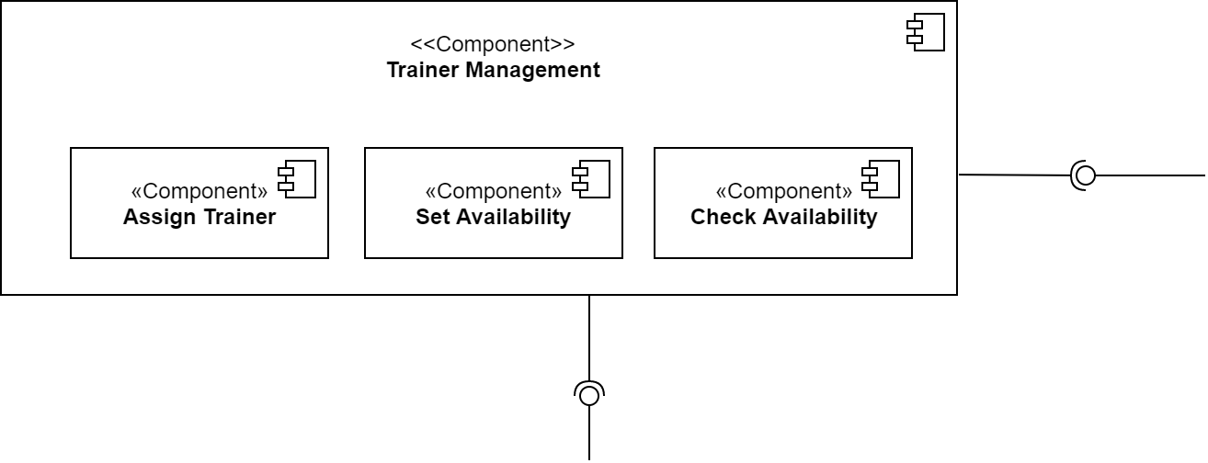

Trainer management component consist of three sub components. Assign trainer, Set availability and check availability.

**Assign trainer**

Assign trainer component is responsible for assigning a trainer to a member. Member can select a trainer if the trainer assign limitation has not exceeded. That limitation is controlled by the assign trainer component.

**Set availability**

Trainer can set his availability during a particular week. That function is facilitated by the set availability component. The component checks the academy open close times before setting the availability of a trainer.

**Check availability**

Check availability component is responsible for showing the availability of a trainer to his/her assigned members. So that members can check the availability and book corresponding trainer.

### **Progress Management Subsystem**

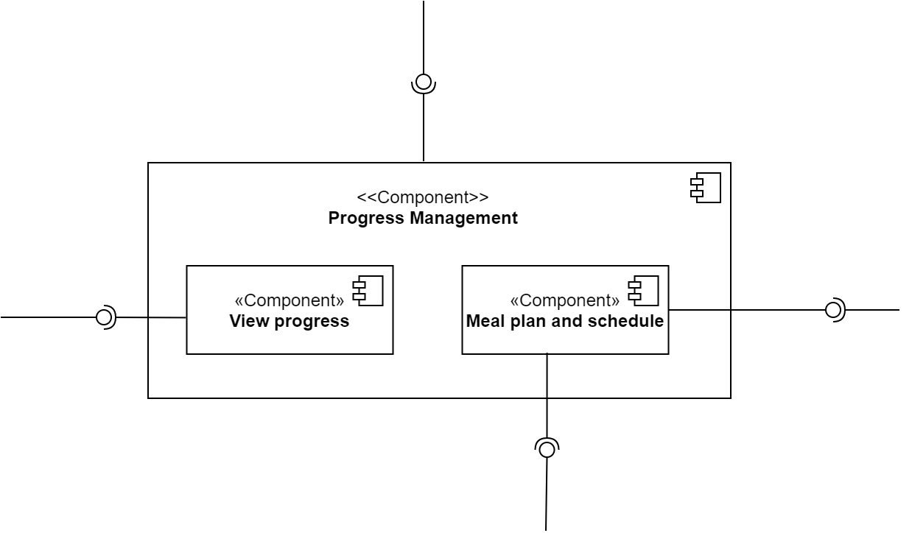

Progress management component consist of two subcomponents. View progress, Meal plan and schedule.

**View progress**

View progress component is responsible for showing the progress of the member. That progress is visible for assigned trainer as well.

**Meal plan and schedule**

This component allows view and update the meal plan and schedule for both the member and his/her trainer.

## **Component Interaction Diagram**

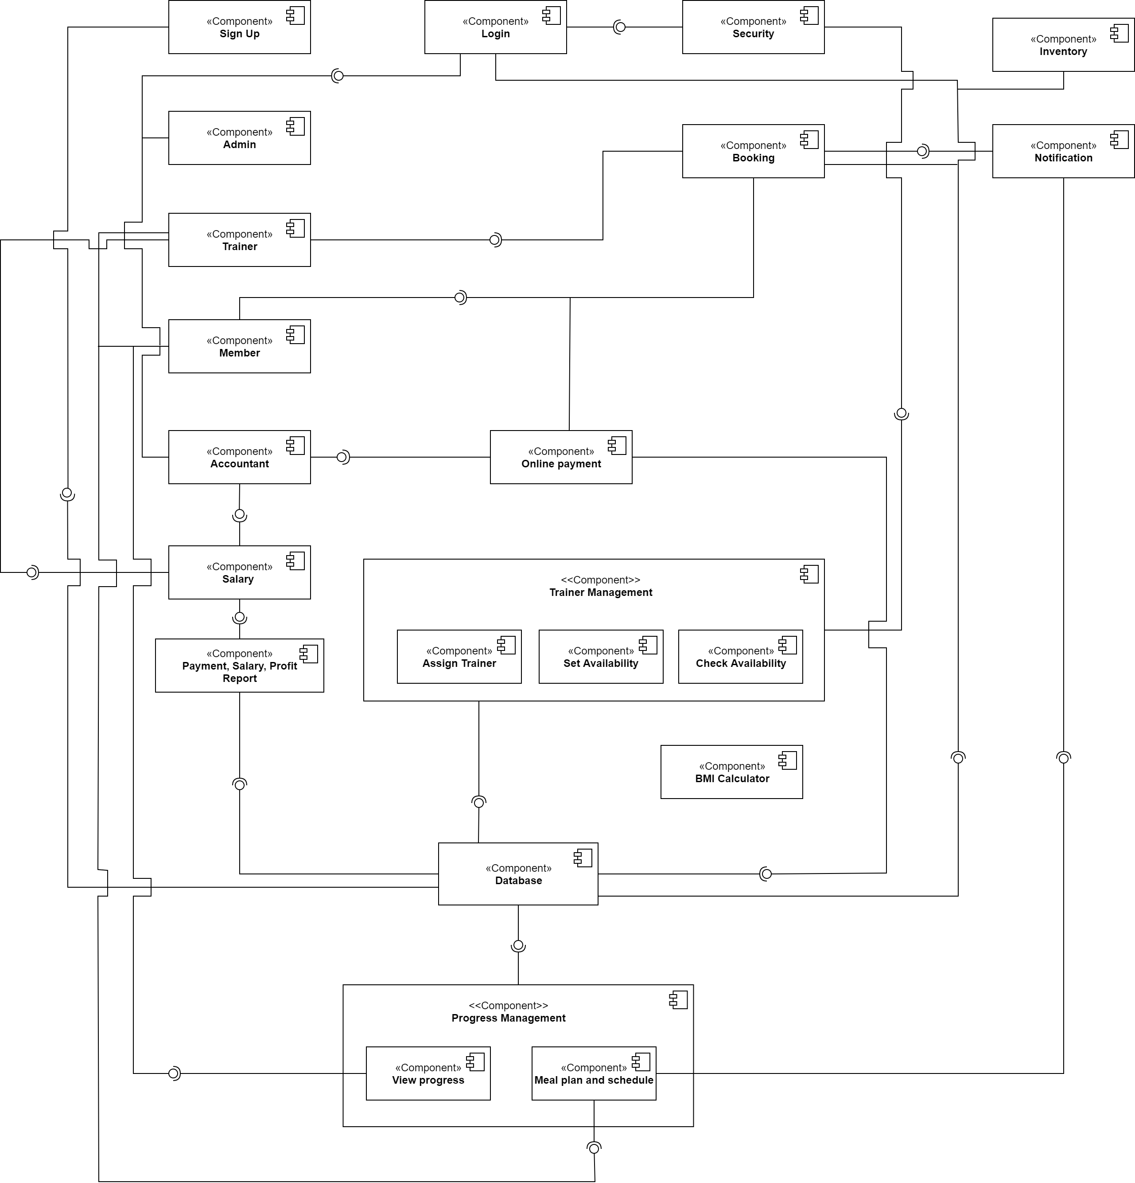

**Figure 6.1: Component Diagram**

# **System’s Design**

## **Class Diagrams**

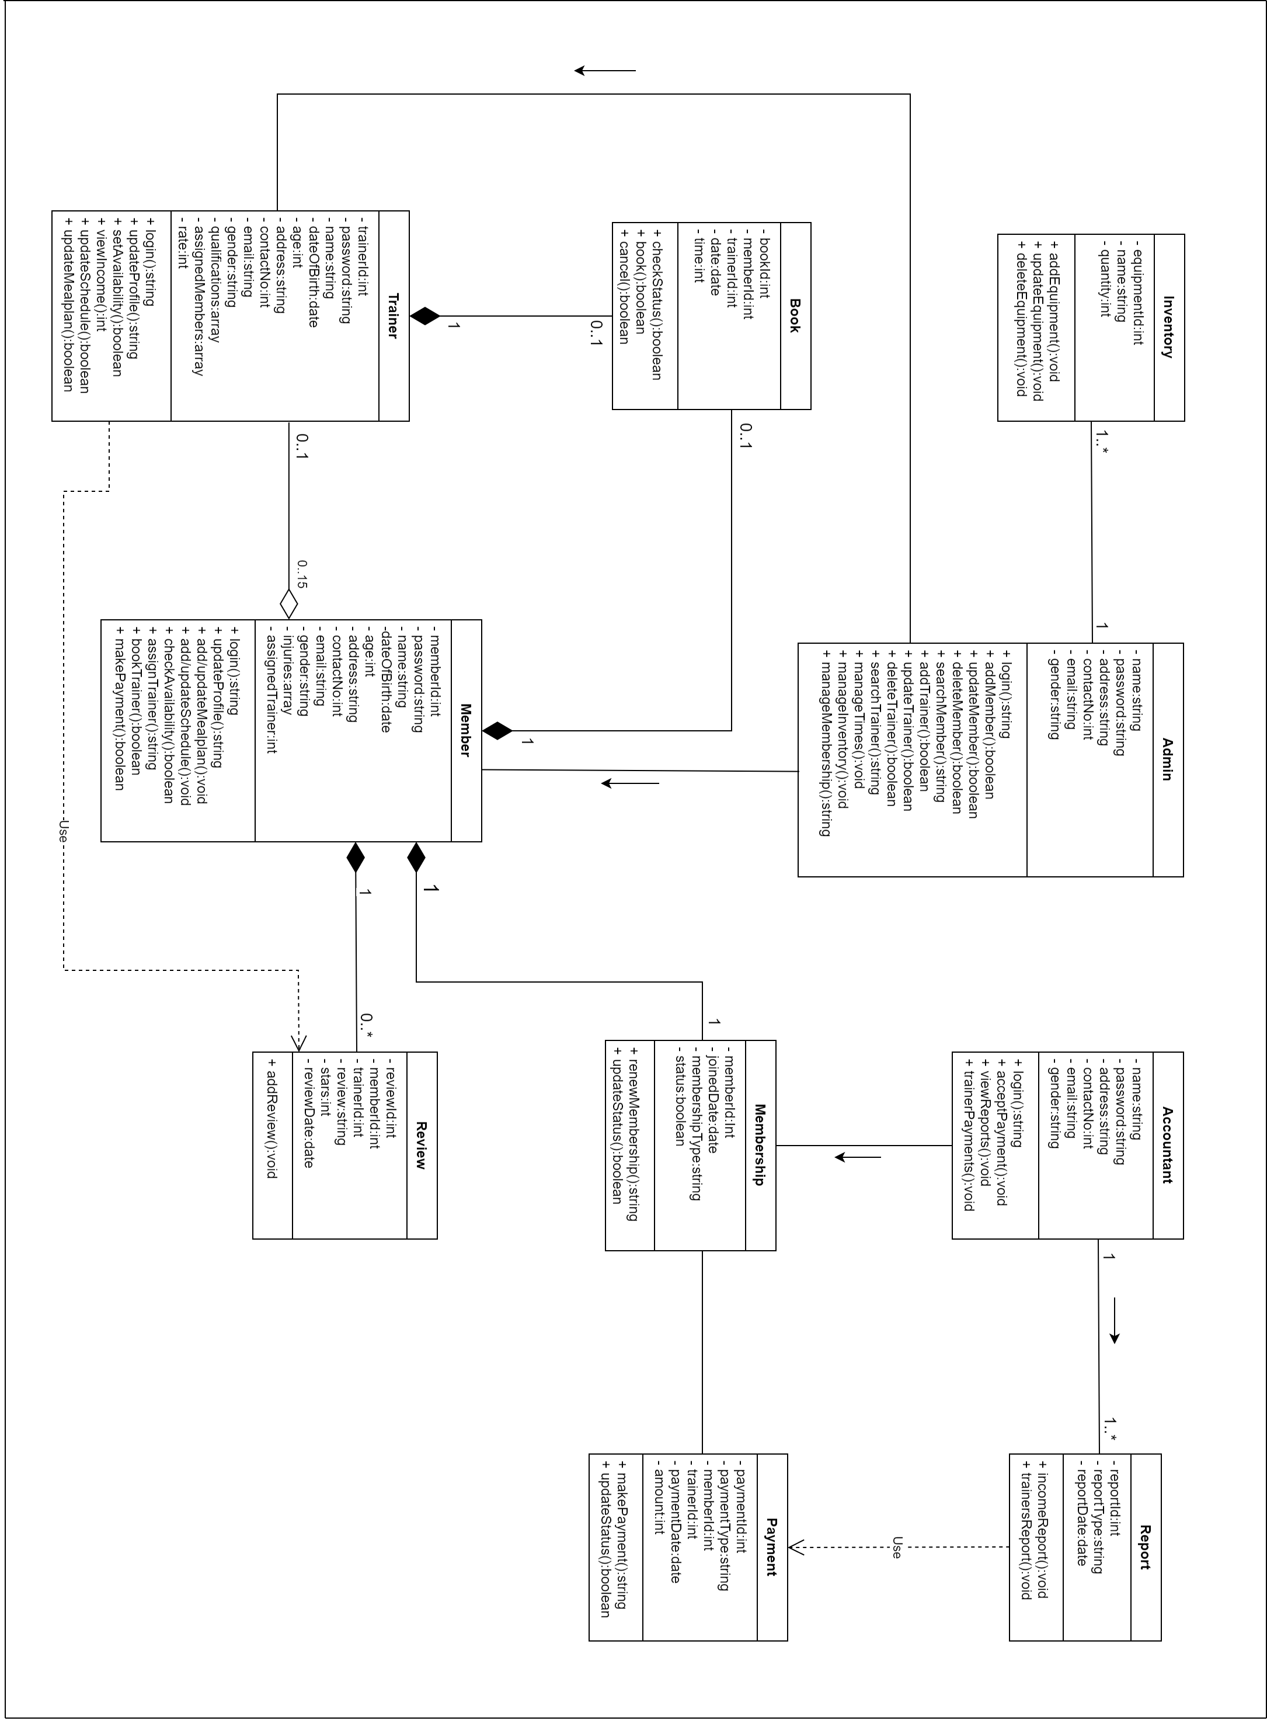

## **ER Diagrams**

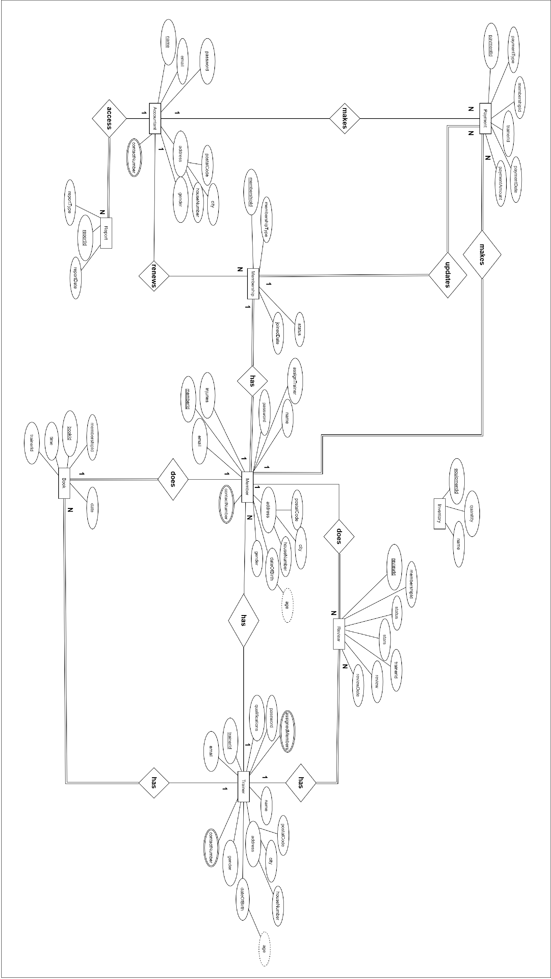

## **Sequence Diagrams**

### **SignUp**

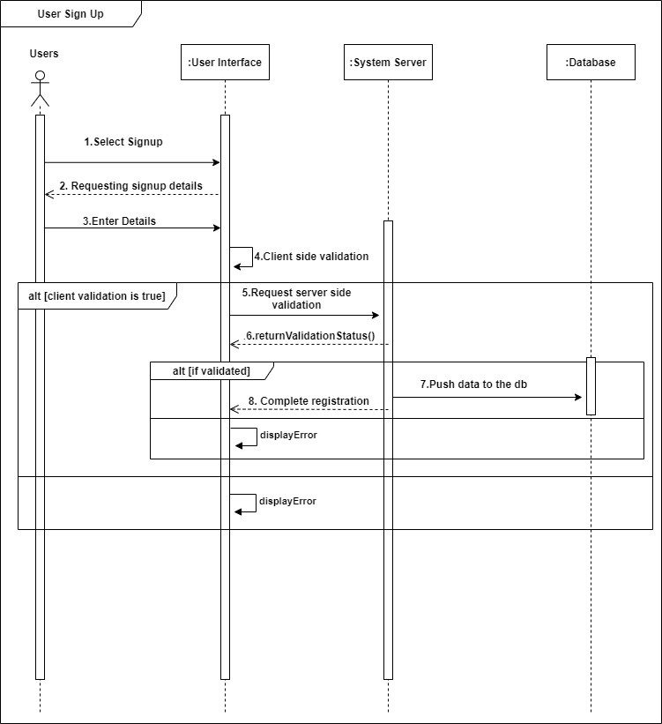

### C:\Users\ACER\Desktop\Diagram Images\Sequence\02.Sequence Diagram-login.png**Login**

### **Add Users**

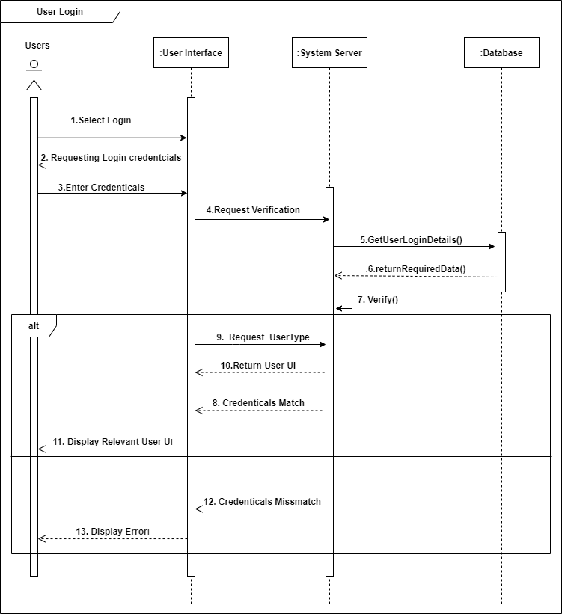

### **Search Users**

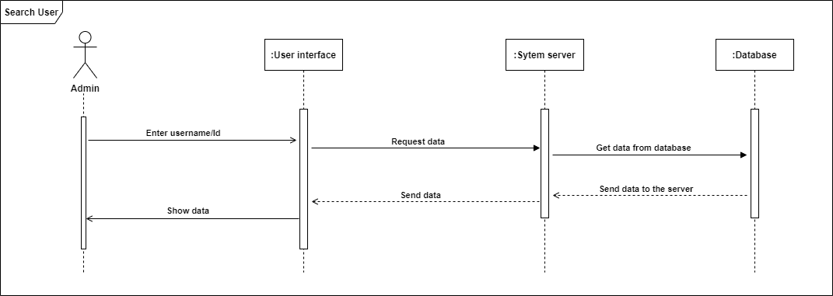

### **Delete Users**



### C:\Users\ACER\Desktop\Diagram Images\Sequence\06Sequence Diagram-Update Users.png**Update Users**

### C:\Users\ACER\Desktop\Diagram Images\Sequence\07times.png**Set open/close date and times**

### C:\Users\ACER\Desktop\Diagram Images\Sequence\07times.png**Set Availability**

### **Assign to a trainer**

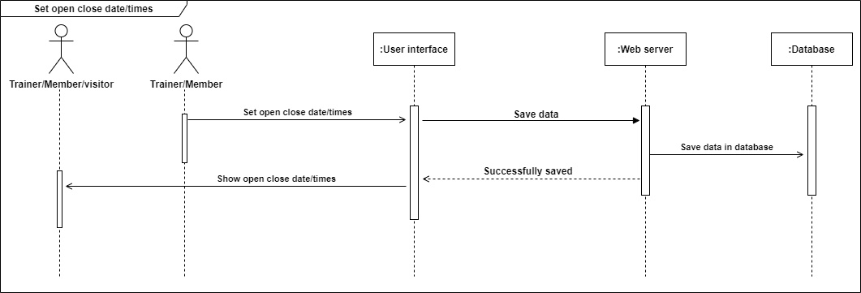

### **Renew Membership**



### C:\Users\ACER\Desktop\Diagram Images\Sequence\07times.png**Update Meal plan and schedule**

### **Calculate BMI**

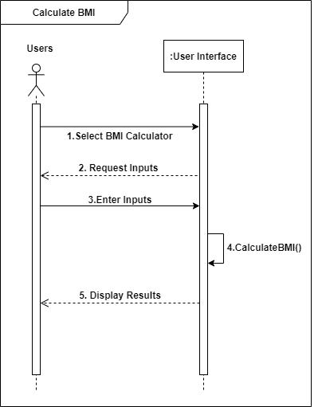

### **Book Trainer**

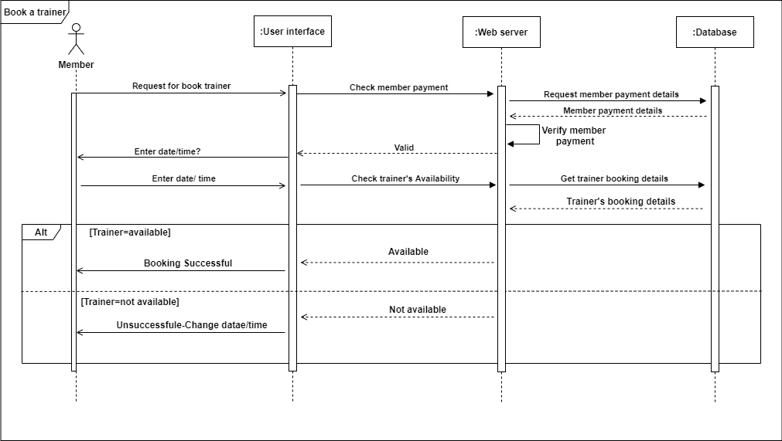

## **Activity Diagrams**

### C:\Users\ACER\Desktop\Activity last edit-Sign Up.png**Sign Up**

**Figure 7.1: Activity Diagram - Sign Up**

### **Login**

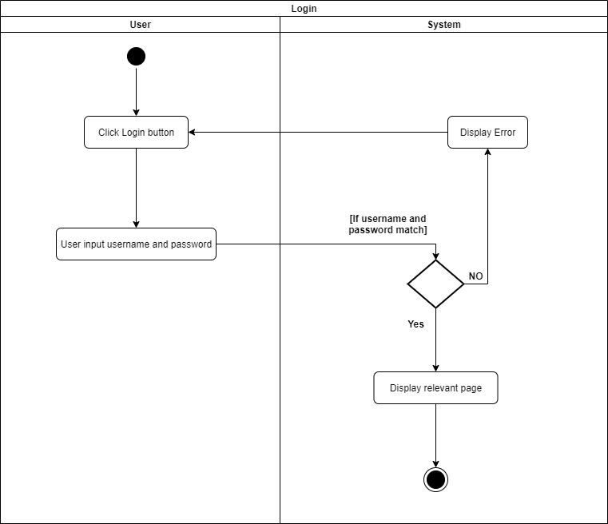

**Figure 7.2: Activity Diagram - Login**

### **Add User**

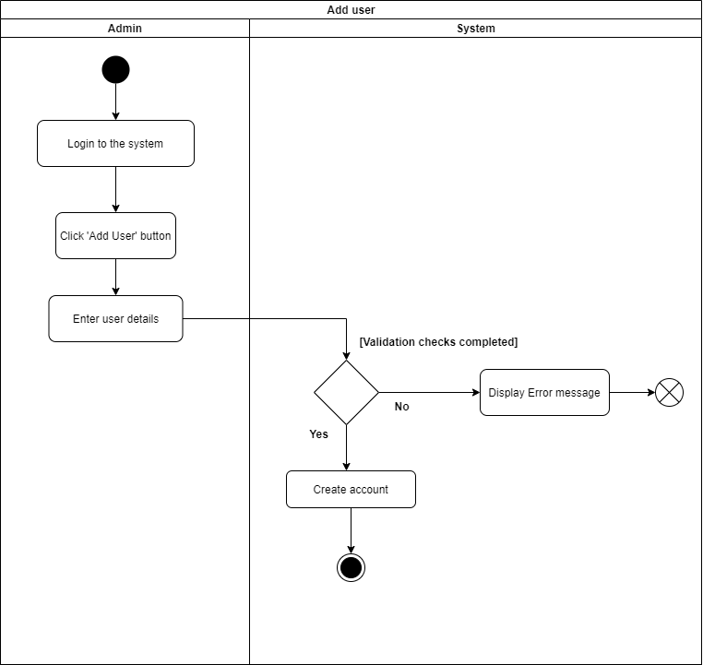

**Figure 7.3: Activity Diagram - Add User**

### **Search User**

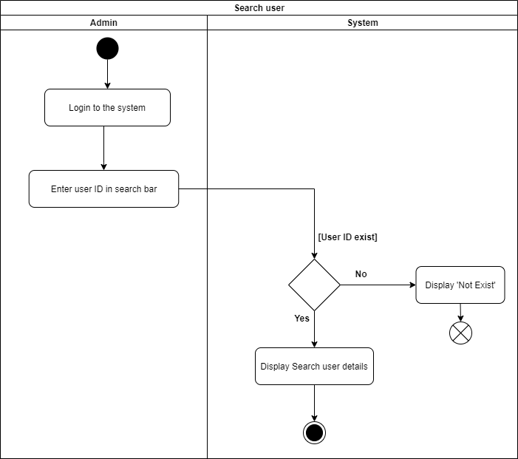

**Figure 7.4: Activity Diagram - Search User**

### **Delete User**

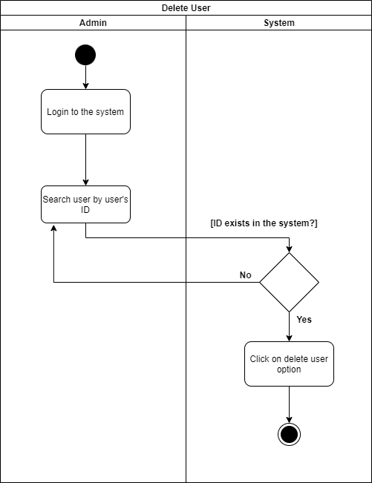

**Figure 7.5: Activity Diagram - Delete User**

### **Manage Inventory**

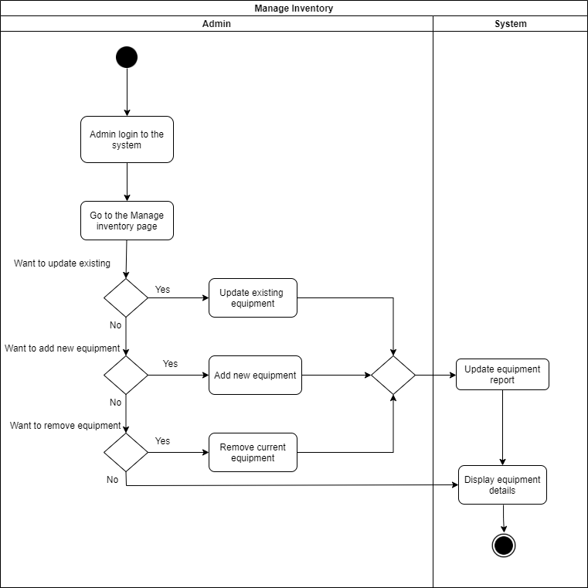

**Figure 7.6: Activity Diagram - Manage Inventory**

### **View Income Report**

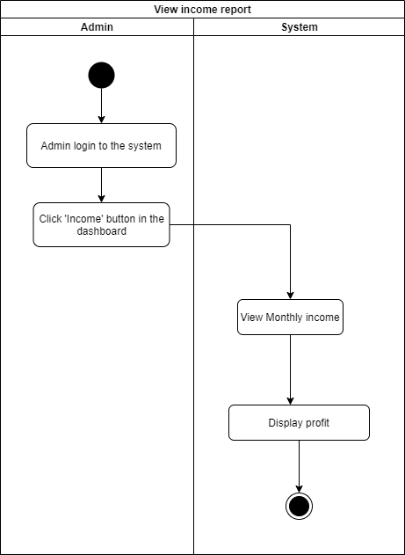

**Figure 7.7: Activity Diagram - View income Report**

### **Manage open/close date and time**

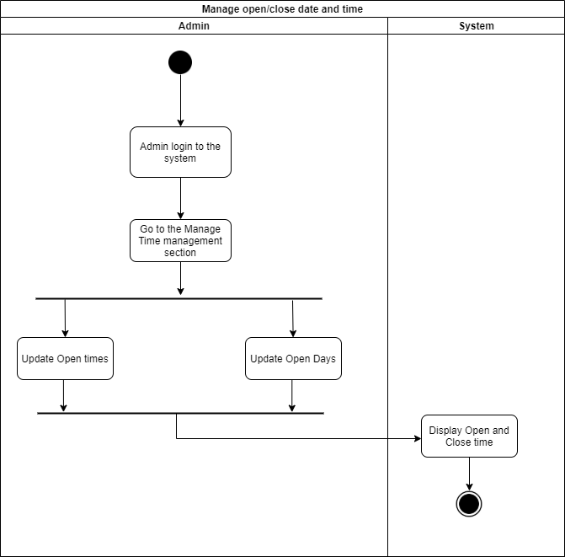

**Figure 7.8: Activity Diagram - Manage open/close date and time**

### **Update Trainer Details**

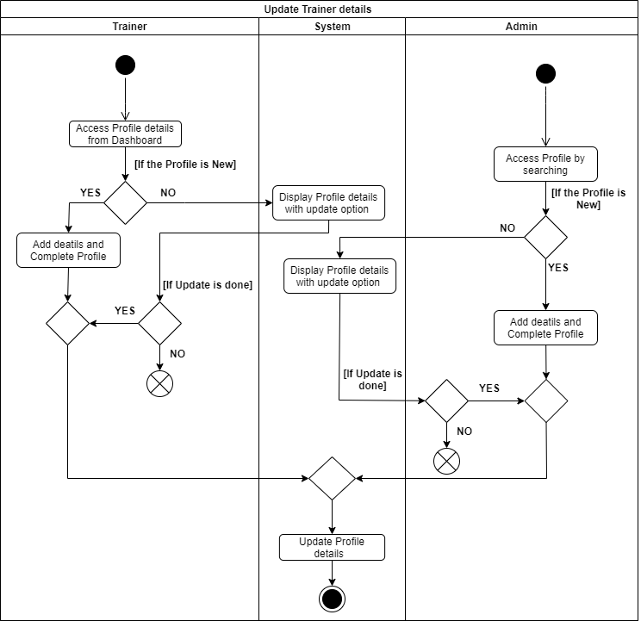

**Figure 7.9: Activity Diagram - Update Trainer Details**

### **View Income**

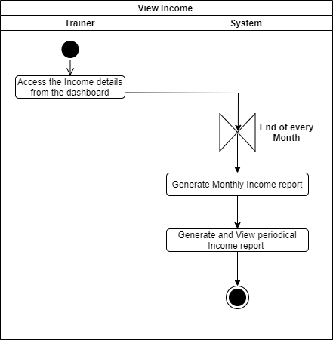

**Figure 7.10: Activity Diagram - View Income**

### **Set Availability**

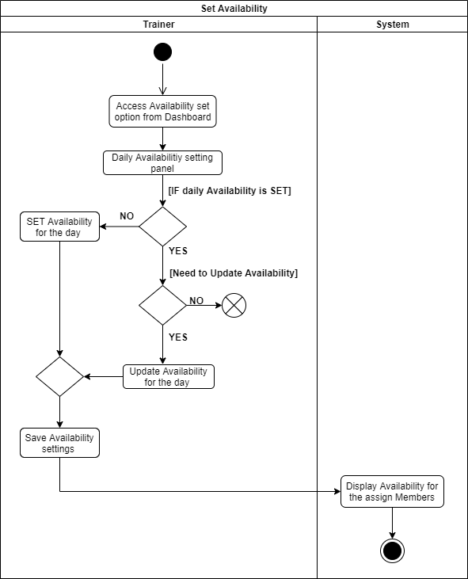

**Figure 7.11: Activity Diagram - Set Availability**

### **View Assign Users**

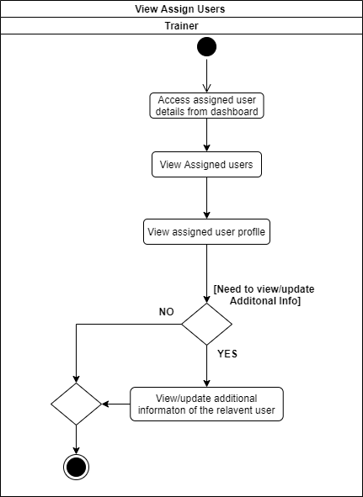

**Figure 7.12: Activity Diagram - View Assign Users**

### **Update Profile Details**

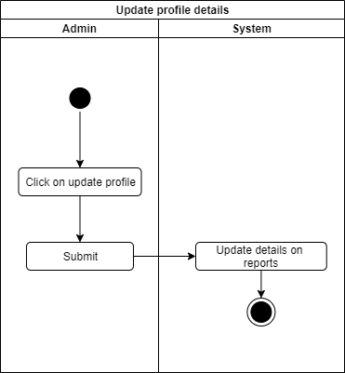

**Figure 7.13: Activity Diagram - Update Profile Details**

### **Assign Trainer**

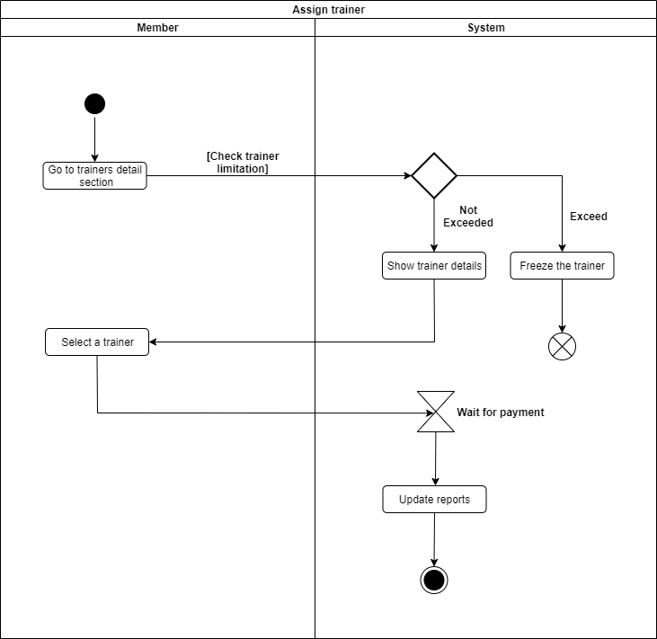

**Figure 7.14: Activity Diagram - Assign Trainer**

### **Check Trainer Availability**

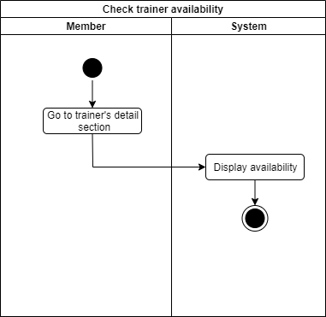

**Figure 7.15: Activity Diagram - Check Trainer Availability**

### **C:\Users\ACER\Desktop\Renew membership.pngMake Payments / Renew Membership**

**Figure 7.16: Activity Diagram - Make Payments/Renew Membership**

### **View Progress**

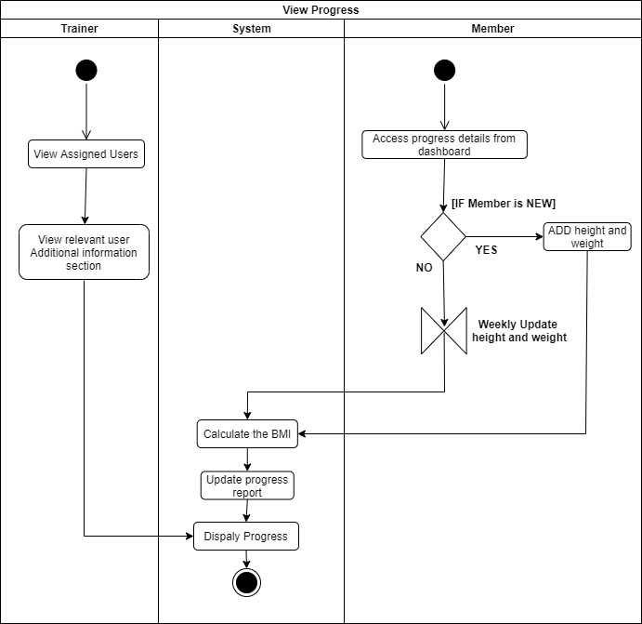

**Figure 7.17: Activity Diagram - View Progress**

### **Add/Update Meal plan and schedule.**

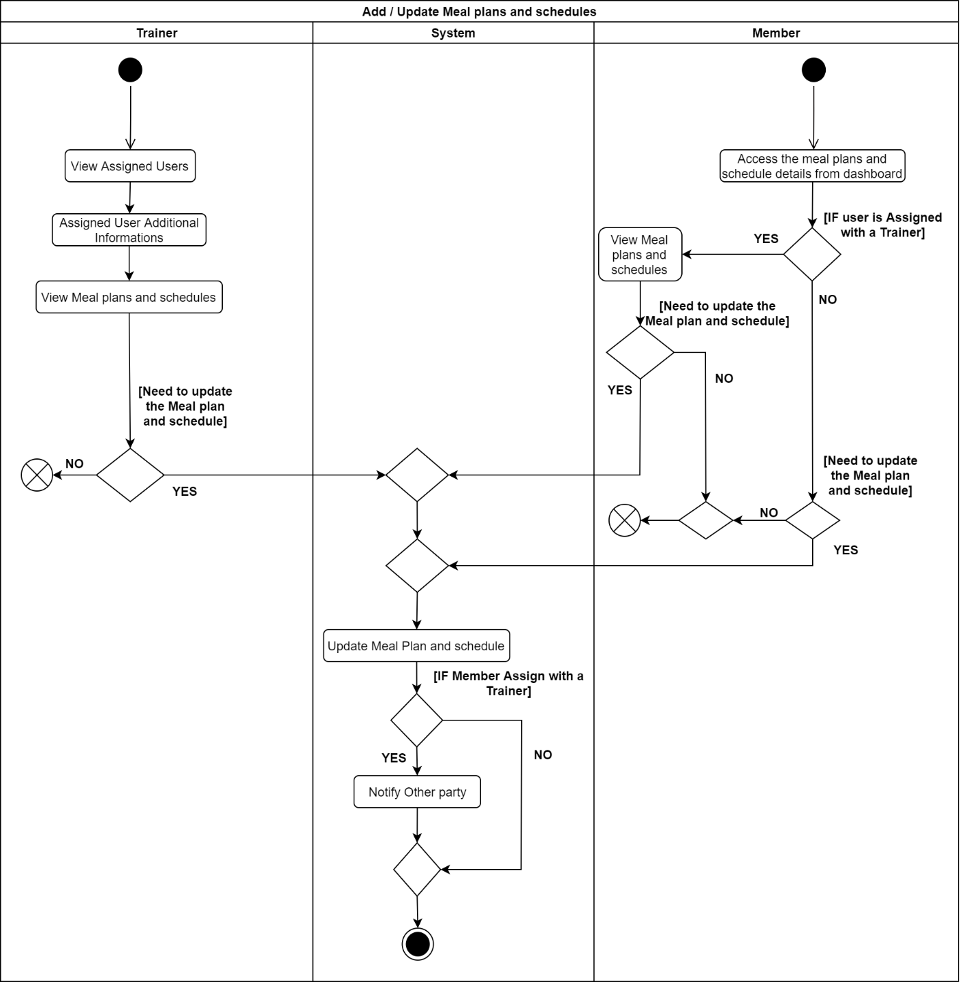

**Figure 7.18: Activity Diagram – Add/Update Meal plan and Schedule**

### **Calculate BMI**

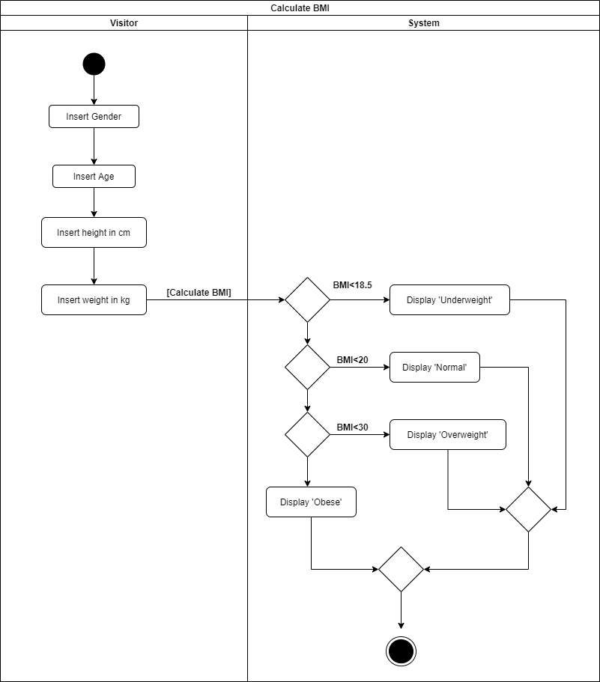

**Figure 7.19: Activity Diagram - Calculate BMI**

### **Book a Trainer**

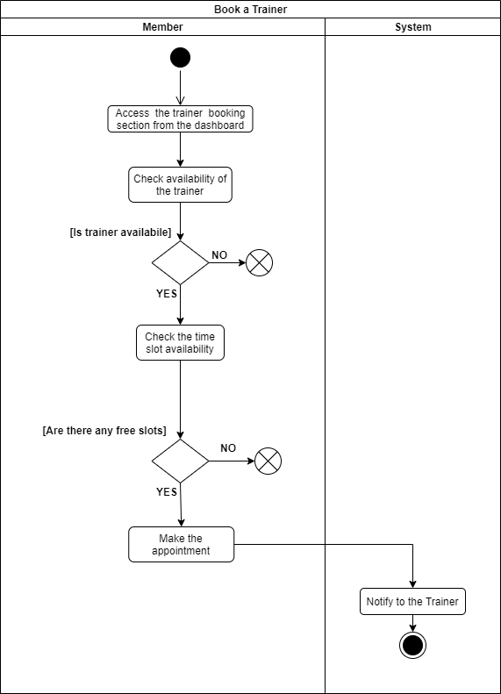

**Figure 7.20: Activity Diagram - Book a Trainer**

### **Check payment details for trainers.**

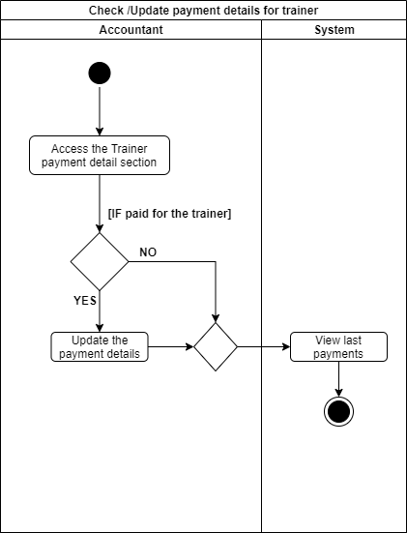

**Figure 7.21: Activity Diagram - Check Payment Details for Trainers**

## **State Transition Diagrams**

### **SignUp**

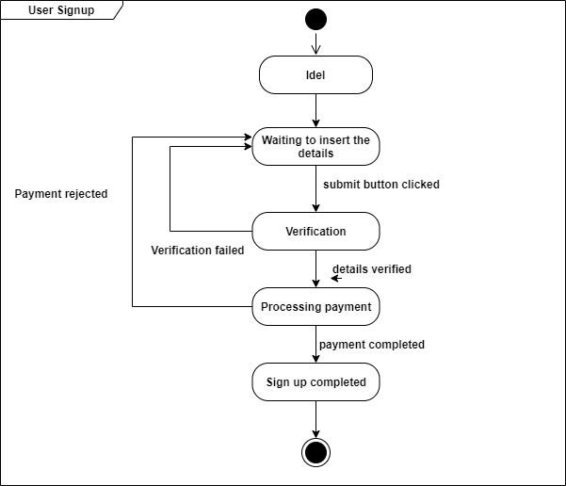

### **Login**

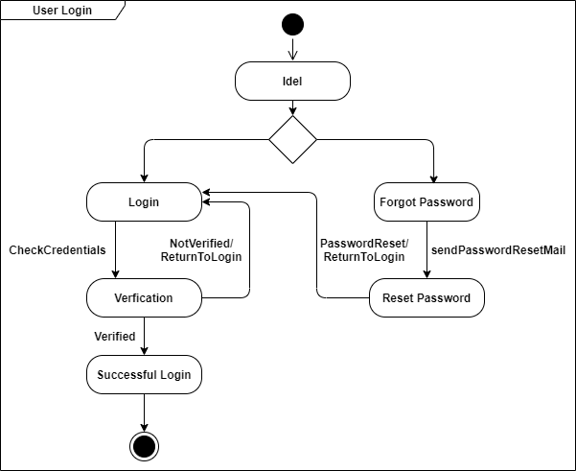

### **Add Users**

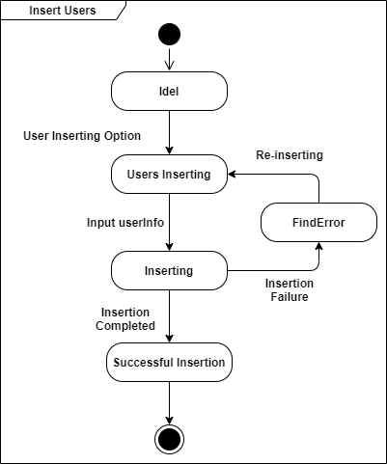

### **Search Users**



### **Delete Users**

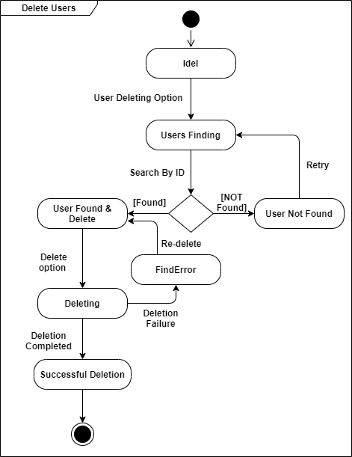

### **Update Users**

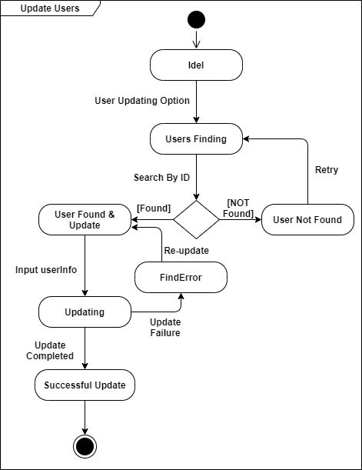

### **Assign to a trainer**

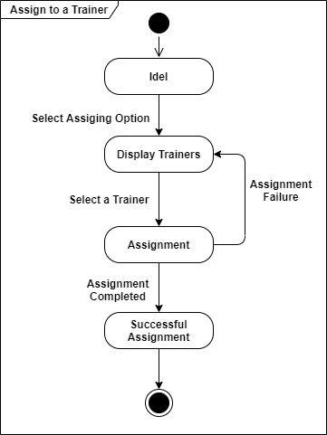

### **Renew Membership**

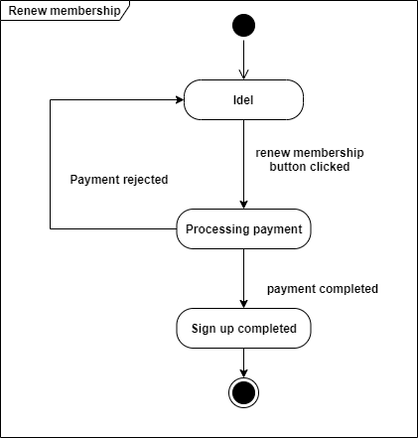

### **Update Meal plan and schedule**

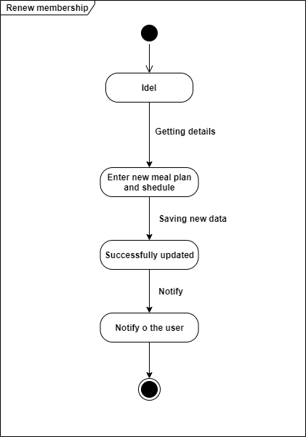

### **Calculate BMI**

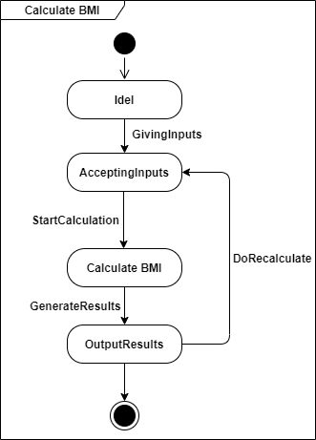

### **Book Trainer**

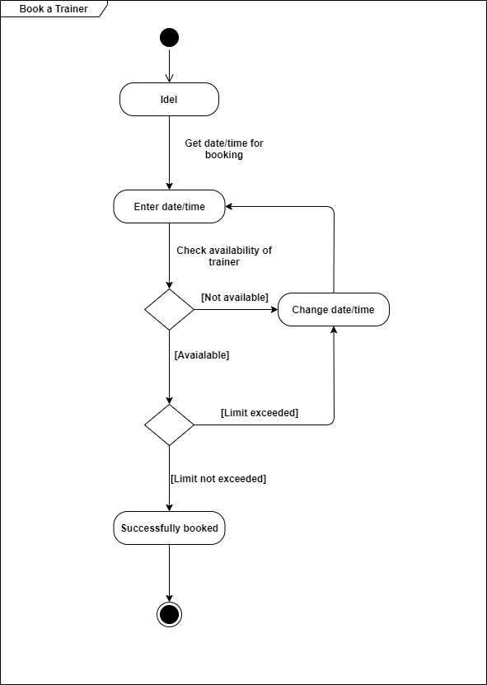

# **User Interface Flow Diagram using wireframes**

## **User Interface Flow Diagram**

* User interface flow diagram for Visitors,Trainers and members is as follows;

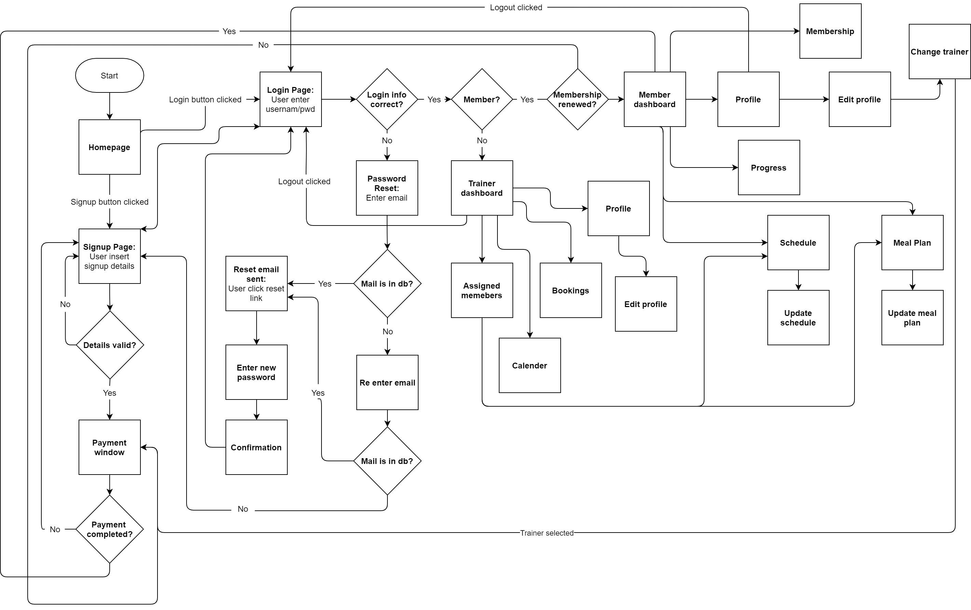

* User interface flow diagram for Admin and Accountant is as follows;

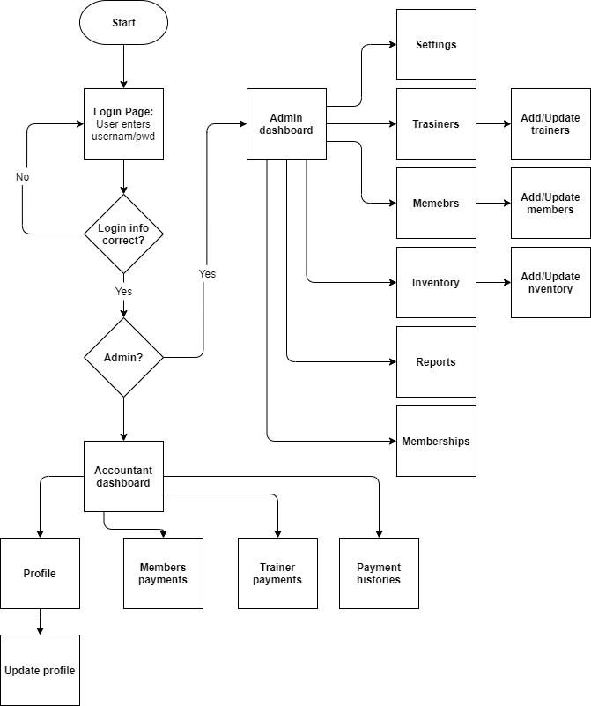

## **Wireframes**



